Awaken For Wellness Massage Therapy Intake Form

Name:___________________________________________________ Today’s date:____________Birth date:_______________
Email:___________________________________________________ Occupation:__________________________
Phone: Day(______)__________________ Eve(______)_______________ Cell(_____)________________
Physician:__________________________________________________________Phone:(_____)____________________
Emergency contact:________________________Relationship:___________________Phone:(_____)_________________
Please answer the following questions by circling the appropriate answer: (If “yes”, please write description on back)
Have you had a professional massage before?.......................................................................... yes no
Please order 1 to 5 your reason for seeking massage: (1 being top priority)
Heal Injury___ Headaches___ Relax___ Pain___ Tension___
Other reasons?________________________________________________________________
When you receive massage, would you say that you enjoy deep pressure? Yes No comment:__________________
Are you currently on any medication (including pain killers/OTCs)…….…………………………………. yes no
Do you wear contact lenses?........ yes no Do you wear dentures?...................... yes no
Do you exercise regularly or participate in any sports?............................................................. yes no
Are you sensitive to perfumes, lotions, or oils?......................................................................... yes no
Do you have any skin problems or allergies?............................................................................. yes no
Do you have any heart problems?............................................................................................. yes no
Do you have high blood pressure?............................................................................................. yes no
Do you have varicose veins or blood clots?............................................................................... yes no
Do you have arthritis, osteoporosis, brittle bones, or spinal problems?................................... yes no
Do you have lung or breathing problems?................................................................................. yes no
Do you have digestive tract problems?...................................................................................... yes no
Are you pregnant?...................................................................................................................... yes no
Have you suffered any acute injuries or illnesses, or been hospitalized in the last year?......... yes no
Are you seeing a psychologist or counselor?.............................................................................. yes no
Do you have any other health concerns I should be aware of?.................................................. yes no
Mark any areas of tension or soreness you would like therapist to address on figures below:
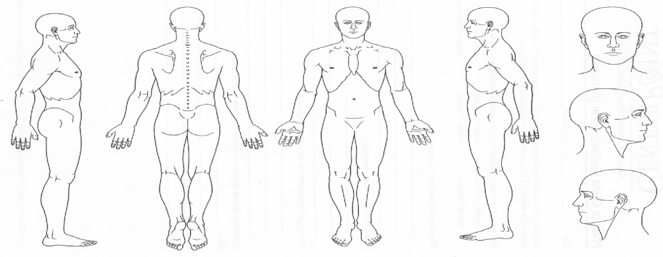

Medications: __________________________________________________________________________________
__________________________________________________________________________________
Exercise or sports:
Type:____________________________________________ How often: ____________________________
Type: ____________________________________________ How often: ____________________________
Skin problems or allergies:
Where:___________________________________________________________________________________
Medical opinion and treatment for:____________________________________________________________
Heart Problems:
Medical opinion and treatment for:_____________________________________________________________
_________________________________________________________________________________________
Blood Pressure Problems:
Medical opinion and treatment for:_____________________________________________________________
__________________________________________________________________________________________
Varicose veins or Blood clots:
Where:____________________________________________________________________________________
Medical opinion and treatment for:_____________________________________________________________
__________________________________________________________________________________________
Arthritis, osteoporosis, brittle bones, or spinal problems:
Where:___________________________________________________________________________________
Medical opinion and treatment for:_____________________________________________________________
__________________________________________________________________________________________
Lung and Breathing Problems:
Medical opinion and treatment for:_____________________________________________________________
__________________________________________________________________________________________
Digestive tract problems:
Medical opinion and treatment for:_____________________________________________________________
__________________________________________________________________________________________
Acute injuries:
Type:__________________________________________ When:_____________________________________
Type:__________________________________________ When:_____________________________________
Type:__________________________________________ When:_____________________________________
Surgeries:
Type:__________________________________________ When:_____________________________________
Type:__________________________________________ When:_____________________________________
Type:__________________________________________ When:_____________________________________
If you are seeing a therapist or counselor, are there issues in that work that may impact receiving massage?

Any other conditions the massage therapist should be aware of:

I understand that the massage therapy given here is for the purpose of stress reduction, relief from muscular tension or spasm, or for increasing energy flow. I understand that the massage therapist does not diagnose illness, disease, or any other physical or mental disorder. As such, the therapist does not prescribe medical treatment or pharmaceuticals, nor do they perform any spinal manipulations. I understand that massage therapy is not a substitute for medical treatments and/or diagnosis and that it is recommended that I see a physician for any physician for any physical ailments that I may have. I have stated all my known medical conditions and take it upon myself to keep the massage therapist updated on my physical health. I have received and agree to the “client bill of rights” form as well as all content within this intake form.

Client Signature:________________________________________________________Date:________________________

